SE401 – Assignment 8.1

Solve the following questions and submit your answers to LMS.

Homework Tips Checklist for Parents

# Questions

**Question 1**

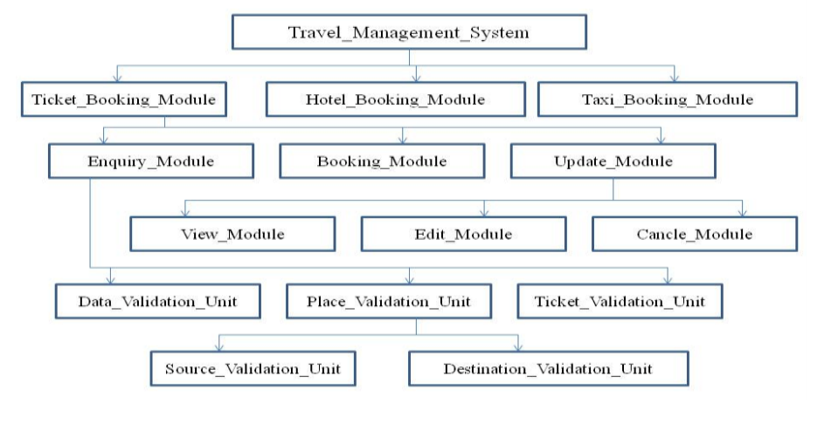

Consider the scenario of development of software for Travel Management System (TMS) is in progress. The TMS software has 3 major modules namely:

* Ticket_Booking_Module
* Hotel_Booking_Module
* Taxi_Booking_Module.

The Ticket_Booking_Module has 3 sub modules namely

* Enquiry_Module
* Booking_Module
* Update_Module

The enquiry module uses

* Date_Validation_Unit
* Ticket_Validation_Unit
* Place_Validation_Unit.

In the context of the given scenario, identify the usage of stub or driver for the following situations.

1. Except the Ticket_validation_Unit, the coding and unit testing of all other modules, sub modules and units of TMS are completed. The top-down integration is in progress for the TMS software. To carry out the integration testing, which among the following is necessary?

* A Stub for Ticket_Validation_Unit
* A Driver For Ticket_Validation_Unit
* A Stub for Enquiry_Module
* A Driver for Enquiry_Module
* A Stub For Ticket_Booking_Module
* A Driver For Ticket_Booking_Module

1. The coding and unit testing of all the module, sub modules and units of TMS are completed except the Update_Module (coding and testing for Edit_Module, Cancel_Module and View_Module are also completed). The bottom-up integration is to be started for the TMS software. Mention any stub or driver needed to carry out the integration testing?
2. Except the Taxi_Booking_Module, the coding and unit testing of all other modules, sub modules and units of TMS are completed. The top-down integration is to be started for the TMS software. Mention any stub or driver needed to carry out the integration testing.

**Question 2**: Describe the difference between unit testing and integration testing?

**Question 3**: Why should integration testing be performed? What types of errors can this phase of testing reveal?

**Question 4**: Using the module hierarchy given in the following Figure, show the orders of module integration for the top-down and bottom-up integration approaches. Estimate the number of stubs and drivers needed for each approach. Specify the integration testing activities that can be done in parallel, assuming you have three engineers. Based on the resource needs and the ability to carry out concurrent activities, which approach would you select for this system and why?

